**Program Development Worksheet:**

Set Up/ Planning Type of Program:  Script  Function

1. Problem Statement:

A GUI to display the projected rate of calorie loss per minute for a user. Program takes into account the user’s height weight and velocity to calculate calories burnt.

1. Inputs: (full name, variable to be used, units)

|  |  |  |  |
| --- | --- | --- | --- |
| Variable Name | Description | Units or Values | Input Source* |
| h | Height of user | feet | GUI slider |
| w | Weight of user | Kg | GUI sider |
| a | Acceleration of user | m/s2 | Mobile accelerometer |

* Possible sources: command line, file, interactive input

1. Output: (full name, variable to be used, units)

|  |  |  |  |
| --- | --- | --- | --- |
| Variable Name | Description | Units or Values | Output type* |
| t | Time plotted on GUI | s | GUI axis |
| cals | Calories burnt per minute plotted on GUI | cal/min | GUI axis |
|  |  |  |  |

* Possible types: command line, file, display

4. Validation:

*Calories burned per minute = (0.035 * body weight in kg) + ((Velocity in m/s ^ 2) / Height in m)) * (0.029) * (body weight in kg)*

This formula may be used to verify whether the GUI plot makes sense for given height, weight and accelerometer data.

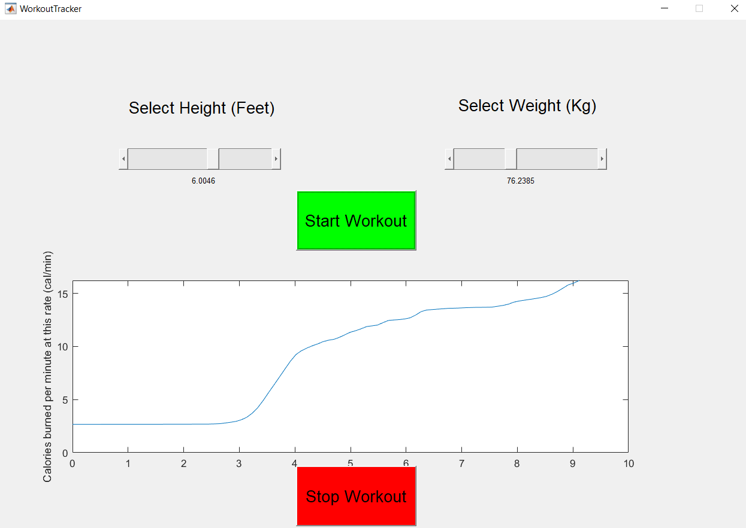

Figure 1 Starting application and beginning walk

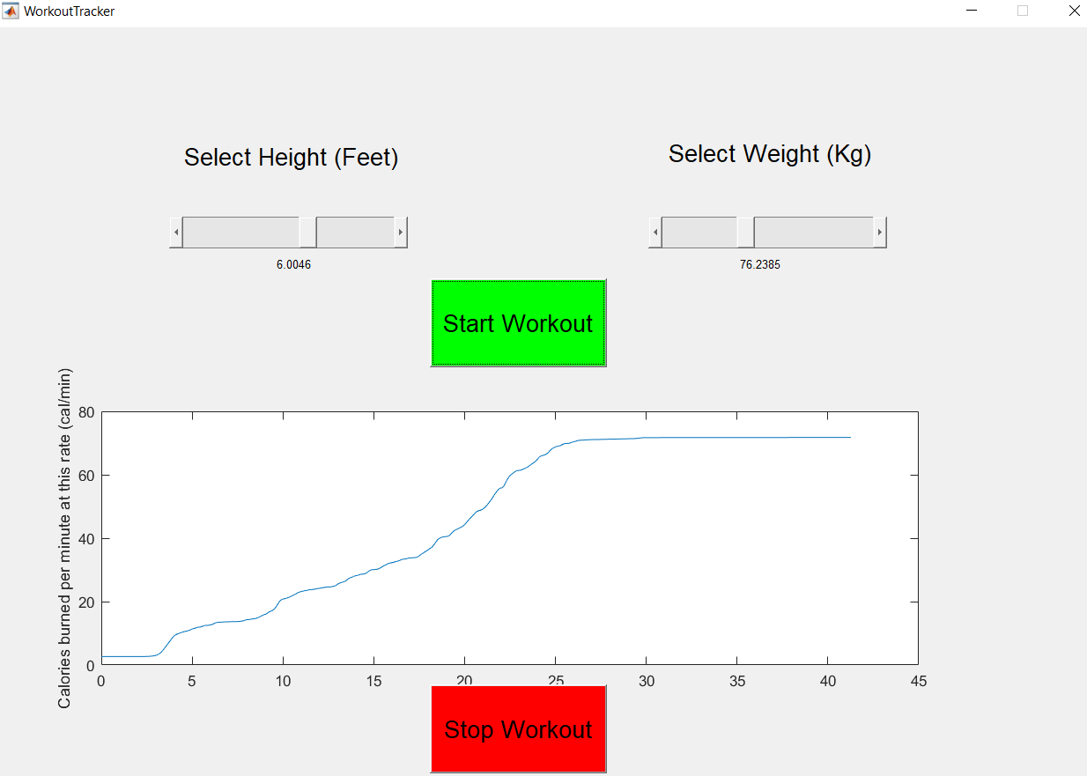

Figure 2 Plot flattens when idle when walk ends